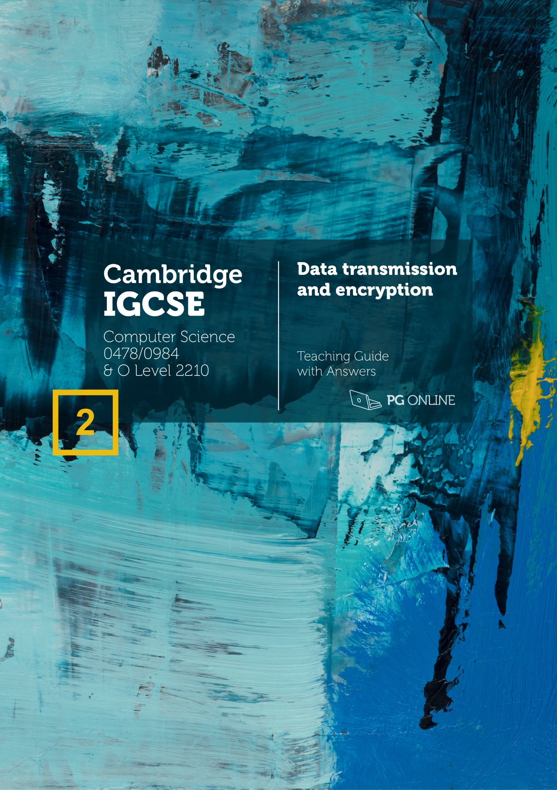
Copyright
© 2021 PG Online Limited
The contents of this unit are protected by copyright.
This unit and all the worksheets, PowerPoint presentations, teaching guides and other associated files distributed with it are supplied to you by PG Online Limited under licence and may be used and copied by you only in accordance with the terms of the licence agreement between you and PG Online Limited. Except as expressly permitted by the licence, no part of the materials distributed with this unit may be used, reproduced, stored in a retrieval system, or transmitted, in any form or by any means, electronic or otherwise, without the prior written permission of PG Online Limited.
Licence agreement
This is a legal agreement between you, the teaching institution, and PG Online Limited. PG Online Limited grants to you a non-exclusive, non-transferable, revocable licence to use this unit and all the worksheets, PowerPoint presentations, teaching guides and other associated files distributed with it in the course of teaching by your teachers and/or employees.
The materials distributed with this unit may be copied and used by your teachers and/or employees on a single site only in the course of their teaching. You warrant that you shall not, and shall procure that each of your teachers and/or employees shall not, share in any way any of the materials or part of the materials with any third party, including users on another site or individuals who are teachers and/or employees of a separate institution. You acknowledge and agree that the materials must remain with you, the teaching institution, and no part of the materials may be transferred to another institution. You also warrant that you shall not, and shall procure that each of your teachers and/or employees shall not, procure, authorise, encourage, facilitate or enable any third party to reproduce these materials in whole or in part without the prior permission of PG Online Limited.
In consideration of the licence granted to you, you shall indemnify PG Online Limited against all liabilities, costs, expenses, damages and losses (including but not limited to any direct, indirect or consequential losses, loss of profit, loss of reputation and all interest, penalties and legal costs and all other professional costs and expenses) suffered or incurred by PG Online Limited arising
Teacher’s Guide
Introduction
This teacher’s guide contains a detailed lesson plan to accompany the set of PowerPoint slides and worksheets for each topic.
The lesson plans are designed to form a basis for ideas for the teacher and should be adapted to suit the teaching style and preferences of the individual teacher, and the resources and nature of the individual school or Computer Science department.
The material supplied for this unit includes:
- 4 PowerPoint presentations, each designed to cover one topic, which may take more than one lesson
- 4 worksheets
- 4 homework sheets
- An end-of-unit test for assessment purposes
Summary
The unit is subdivided into four topics and an end-of-unit assessment. Each topic is designed to give enough materials for approximately 1 hour of teaching time, however, this will differ depending on how much depth is considered and whether homeworks are reviewed in the following lesson. The unit covers Section 2.1, 2.2 and 2.3 of the Cambridge International iGCSE Computer Science 8525 0478/0984 specification.
Types and methods of data transmission, methods of error detection and encryption are all covered. In the final lesson students sit an assessment test comprising questions similar to those found on the iGCSE exam paper.
Learning Outcomes for the unit
At the end of this Unit all students should be able to:
- Understand that data is broken down into packets to be transmitted
- Describe how data is transmitted from one device to another using different methods of data transmission including:
- Simplex, Half-duplex, Full-duplex
- Describe each of the following error detection methods:
- Parity check (odd and even)
- Checksum
- Echo check
- Understand how data is encrypted using symmetric encryption
Most students will be able to:
- Describe the structure of a packet including
- Packet header (destination address, packet number, originator’s address)
- Payload
- Trailer
- Describe the process of packet switching including:
- Packets, routing, routers, packet order and reordering
- Describe how data is transmitted from one device to another using different methods of data transmission including:
- Serial, Parallel
- Understand the universal serial bus (USB) interface and explain how it is used to transmit data
- Understand the need to check for errors after data transmission
- Describe each of the following error detection methods:
- Parity check (odd and even)
- Describe how check digits are used in data entry including:
- ISBN
- Bar codes
- Understand the need for and purpose of encryption when transmitting data
- Understand how data is encrypted using asymmetric encryption

Some students will be able to:
- Explain the suitability of each method of data transmission for a scenario
- Explain the advantages and disadvantages of each method
- Describe each of the following error detection methods:
- Checksum
- Describe how an automatic repeat query (ARQ) is used to establish data is correctly received
Previous Learning
No prior knowledge is essential with this unit. However, students should have a basic understanding of computer systems from lessons delivered as part of the Key Stage 3 national curriculum.
Suggested Resources
No specific software is required for this unit. It is primarily a theoretical unit that can be taught entirely without computers, but there are some exercises where computers could be used in order to support understanding through practical discovery.

Recommended textbooks
Cambridge IGCSE Computer Science 0478 / 0984 ISBN 978-1-910523-38-4
Experience + revision science + beautiful design = better results

Absolute clarity is the aim with a new generation of IGCSE Computer Science revision guide. This clear study guide has been expertly compiled and edited by successful former teachers of Computer Science, highly experienced examiners and a good dollop of scientific research into what makes revision most effective and more accessible.
Past examinations questions are essential to good preparation, improving understanding and confidence. This guide has combined revision with tips and more practice questions than you could shake a stick at. All the essential ingredients for getting a grade you can be really proud of.
Each specification topic has been referenced and distilled into the key points to make in an examination for top marks. Questions on all topics assessing knowledge, application and analysis are all specifically and carefully devised throughout this book.
This book is suitable for the 0478 9-1 IGCSE, the 0984 A*-G IGCSE and the 2210 O Level for examination in 2023 onwards.
A new generation of revision book to capture students’ attention and make revision more effective and more enjoyable.
- Hundreds of marks worth of examination style questions
- Answers provided for all questions within the books
- Illustrated topics to improve memory and recall
- Specification references for every topic
- Examination tips and techniques
- Free Python solutions pack

Vocabulary
Vocabulary associated with this unit, such as:
Packets, packet header, payload, trailer, destination address, packet number, originator’s address, packet number, packet switching, router, routing, data transmission, serial, parallel, simplex, half-duplex, full-duplex, universal serial bus, USB, error detection, parity check, checksum, echo check, check digit, international standard book numbers, ISBN, bar codes, parity byte, parity block check, automatic repeat query, ARQ, positive acknowledgement, negative acknowledgement, timeout, encryption, symmetric encryption, asymmetric encryption, public key, private key.
Assessment
Homework is given for each lesson. These consist of a mixture of short, factual questions assessing knowledge in isolation and longer questions in which students are asked to analyse a situation or justify their answer to questions.
The final assessment given assesses student’s knowledge of the current unit. In the actual examination, questions may integrate various topics into one question. As such, we strongly encourage teachers to use past papers and specimen papers to assess students and predict outcomes.
Lesson plans
Topic 1 Data packets
Objectives:
- Understand that data is broken down into packets to be transmitted
- Describe the structure of a packet including
- Packet header (destination address, packet number, originator’s address)
- Payload
- Trailer
- Describe the process of packet switching including:
- Packets, routing, routers, packet order and reordering
Content
Starter
PowerPoint Guide: Topic 1 Data packets
Networks have lots of terminology, but students should be aware that much of this comes from traditional forms of communication. Ask students to consider the analogy of how a very large bundle of legal documents could be sent through the postal network. It is likely that they will use terms that are the same as computer networks, such as address and packet. Explain to students that packets in a postal network and cars on a road network (hence terms such as traffic) are good analogies to keep in mind when studying this unit. Answers to the questions are given on the following slide.
Main
Data packets
Now move students to the idea that computers need to send large amounts of data through computer networks. This is broken down into data packets. Students should speculate as to what data each packet will contain. They need to be aware of each of the components listed on the Answers slide.
Hand out Worksheet 1 and ask students to complete Task 1.
Topic 1 Worksheet 1
Topic 1 Worksheet 1 Answers
Packet switching
Before showing this slide, you may wish to students the video:
https://www.youtube.com/watch?v=AYdF7b3nMto
The Internet: Packets, routing and reliability. [6m25s]
This video covers packets, routing and re-sending – which are all components of this lesson.
Ask students to consider the final part of the packet switching process. Once they have answered, go through the answers on the following page.
Packet switched network
This slide asks students to consider a diagram showing a small network (or a small part of the Internet).
Students should be able to identify most of the parts of the network. Ask them to consider this in pairs, then go through the Answers slide that follows.
Ask students to complete Task 2 on Worksheet 1.
Plenary
The plenary gives students the opportunity to revise the key words and concepts from the lesson. Ask them to work in pairs to come up with a description of how information is sent through the Internet using packets, packet switching and routers. Once they have carried this out and written down the different components of each packet, go through the slide that follows.
Hand out Homework 1.
Topic 1 Homework 1
Topic 1 Homework 1 Answers

Topic 2 Data transmission
Objectives:
- Describe how data is transmitted from one device to another using different methods of data transmission including:
- Serial
- Parallel
- Simplex
- Half-duplex
- Full-duplex
- Explain the suitability of each method for a scenario
- Explain the advantages and disadvantages of each method
- Understand the universal serial bus (USB) interface and explain how it is used to transmit data
Content
Starter
PowerPoint Guide: Topic 2 Data transmission
It is possible that students haven’t experienced a tin-can telephone. Explain that it is two cans joined by a string that has tension applied. When a user speaks into the can, the sound waves vibrate the string causing the other to produce the same sound.
This real-world example allows students to see an example of a half-duplex communication system and how it can be improved.
Students are likely to see that there are different advantages and disadvantages with different solutions. In the same way, parallel and serial connection have different benefits and drawbacks. Once students have considered the questions, suggested answers are given on the following slide.
Main
Serial transmission
Introduce serial and parallel data transmission types and explain briefly that with serial, only one signal (or bit) can be sent at a time down a single wire. With parallel, many wires are used to transmit multiple signals simultaneously.
Despite being limited to just one signal at a time, serial transmission can be very quick and is used for broadband Internet cables. It also has the huge benefit that as a single cable, it is smaller, and simpler to produce. Smartphone cables are serial.
Parallel transmission
Parallel has the obvious benefit that many signal (or bits) can be sent simultaneously which makes it immediately faster than serial. However, parallel transmission suffers from problems such as skew and crosstalk. These are discussed later.
Parallel vs serial transmission
The pins that are used to transfer data are indicated on the serial and parallel cables shown. Other pins are used for other uses such as the ground pin or control signals. They are not used for data transmission though. Let students know that they don’t need to remember individual pin uses, however, they should be aware that many more pins are required in the parallel cable.
Topic 2 Worksheet 2
Data cables and the problem with parallel cables
Explain to students that internal hard drives and floppy drives used to be connected with parallel cables like the one shown on the slide. The problem with these cables is that they experience crosstalk and skew which are covered in the next two slides.
Crosstalk
When an electric current is applied to a wire it may affect another nearby wire. On older analogue phones it was sometimes possible to hear conversations from another phone connection. You may wish to explain this to students so that the term is easier to remember.
Explain to students that line D4 in the diagram is being affected by the signals on lines D3 and D5. This has caused the receiver to incorrectly receive a 1 instead of a 0.
Skew
It takes slightly different times to transmit each line’s data. The receiver must wait until all lines have been transmitted before the next block of data may be sent. This ultimately means that there is a limit to the data rate for a parallel cable. This isn’t a problem inside a CPU or even when transferring data a few millimetres from the CPU to RAM. It is however a big problem when transferring data to devices that are metres or more away.
Advantages of serial
If you have any old parallel cables, it would be useful to show these to students so that they have a physical idea of some of the advantages of newer USB cables. Explain to students that USB cables are an example of a serial cable.
Integrated circuits
At this point students should be aware that the rate of data transfer isn’t as simplistic as ‘parallel is faster as it has more lines for transferring data’. USB is serial, but far faster than a parallel printer cable for data transfer. However, CPUs and RAM need to transfer data very quickly. Given the data does not need to be transferred very far, it is possible to successfully transfer the data using parallel connections. The clock on the CPU will determine when all lines must have transferred their data internally.
USB features, benefits and drawbacks
This slide shows the connections on a USB cable. Students are unlikely to have an appreciation of how many problems USB solved. Describe the problems that parallel printer cables had and why USB were superior. One advantage of USB cables is the ability to plug them in and remove them whilst the computer is turned on. This was a much harder problem for programmers to solve than traditional cables. You may wish to show students the short video of Bill Gates struggling to use a USB cable.
Bill Gates and the Windows 98 blue screen [0m29s]
https://www.youtube.com/watch?v=tRtx2SBHcNY
Ask students to complete Task 2 on Worksheet 2.
Simplex, duplex and half-duplex
Demonstrate to students the different metaphors for simplex and duplex transmission in terms of one-way, single and dual carriageway traffic. Half-duplex requires a signal to denote the direction of travel.
You can combine these terms with serial and parallel. For example, a serial, simplex cable would transmit one signal at a time, in one direction only.
Transmission direction
Take students through the example of Walkie Talkies. Just like the tin-can telephone, these are only able to transmit data as half-duplex.
Ask students to complete Task 3 on Worksheet 2.
Plenary
Explain to students that whilst the terms serial, parallel, simplex, half-duplex and full-duplex sound hard, they are actually relatively simple concepts to understand. Explain that they should remember the analogy of cars on a road network, and this should help with recalling the different terms. Once students have had a chance to explain each of the terms to their partner, go through the answers on the following slide.
Hand out Homework 2.
Topic 2 Homework 2
Topic 2 Homework 2 Answers

Topic 3 Error detection
Objectives:
- Understand the need to check for errors after data transmission
- Describe each of the following error detection methods:
- Parity check (odd and even)
- Checksum
- Echo check
- Describe how check digits are used in data entry including:
- ISBN
- Bar codes
- Describe how an automatic repeat query (ARQ) is used to establish data is correctly received
Content
Starter
PowerPoint Guide: Topic 3 Error detection
The aim in reading out the numbers as quickly as possible is to understand that mistakes will be made. Students may be very fast at accurately doing this without any error correction methods. Ask them what they would do to ensure that the data was perfect if they couldn’t quite hear each other. The task may work better by asking students to whisper the numbers to each other. Once students have considered the question, go through the potential answers on the following slide. Students may give other answers. The answers given are similar to an echo check and an ARQ, both of which are covered later in the lesson.
Main
Transmission errors
Go through the possible reasons that transmissions may have errors in them. The last three points on the slide are those given in the specification.
Error checking
Five error checking methods are given on the specification. Each of these are relatively easy to understand, however, it would be helpful to review the list and what they mean at various points in the course as it will be easy for students to forget them.
Parity bits
Parity bits make it possible to see if a set of binary digits (typically 7 bits) have been correctly transmitted. The 8th bit is often used for this as this creates one byte in total.
The communicating computers will first agree if they will use odd or even parity. They will then send the data with the appropriate parity bit. Explain to students that the receiver will know there is an error in the transmitted data, but it won’t know which bit is incorrect, so it will need to request that it is sent again.
Parity block check
Parity bits are shown in diagrams at either the beginning or end of the data. There is no difference in working out how to calculate parity. We show parity at both the start and end of examples so that students will be used to the different places for the parity bit to be shown.
Take students through the slides that demonstrate how, with a parity block check, it is possible to identify which bit has been incorrectly transmitted. The receiver is able to correct the bit without requesting that the sender sends it again.
Hand out Worksheet 3 and ask students to complete Task 1.
Topic 3 Worksheet 3
Checking data entry and check digits
Students will be using check digits all the time in their lives. They probably haven’t considered it until now. If they have seen credit card number entered into a website or scan a barcode with a handheld scanner or at a self-service till, they are making use of check digits on the barcode or card.
ISBN numbers are explicitly mentioned on the specification, so they are covered in detail here. The specification also expects students to be aware of bar codes. UPC is one standard given in the slides. Another standard is the International Article Number, also known as the European Article Number (EAN). Finally, these standards, along with ISBN numbers have all been incorporated into the newer Global Trade Item Number (GTIN). In the case of ISBN numbers, they are a GTIN-13 number that starts with 978 followed by the 10-digit ISBN number.
Ask students to complete Task 2 and Task 3 on Worksheet 3.
Checksums
Both check digits and parity bits are special cases of checksums. The second slide shows how a file can be transmitted along with a checksum to check that the file has transmitted correctly.
Echo check
An echo check is probably the easiest check to understand. It is often used when people are on the phone. The problem with the technique is that a lot of additional transmission is required to carry it out.
ARQs
ARQs allow the receiver to let the sender know that they have (or have not) received each block of data correctly. The sender must wait until a timeout before sending the block of data again. Negative acknowledgements are used to let the sender know that a block of data had a transmission error so needs to be sent again.
Ask students to complete Task 4 on Worksheet 3.
Plenary
This activity is similar to that given in the starter. This time students not only have to consider how they will transmit the data, but also make analogies to how this is done with a computer and make use of the correct technical terminology.
Students may come up with other ideas – for example, letters may be read out using the phonetic alphabets – e.g., alpha, beta, charlie, delta.
This is a little like a checksum or check digit in that the second part of the word confirms whether the first letter was heard correctly. Of course, the analogy isn’t exactly the same – the checksum in the phonetic alphabet is longer than the original letter being read, whereas a checksum is usually significantly shorter than the data being sent.
Hand out Homework 3.
Topic 3 Homework 3
Topic 3 Homework 3 Answers

Topic 4 Encryption
Objectives:
- Understand the need for and purpose of encryption when transmitting data
- Understand how data is encrypted using symmetric and asymmetric encryption
Content
Starter
PowerPoint Guide: Topic 4 Encryption
Ask students to consider their Wi-Fi connection and why it needs encryption. It is likely that students will understand this connection’s security risks better than a cable as it is obvious that the signal can be listened to by others. Remind them that hackers (eavesdroppers) can also listen to cabled connections too.
Once they have had a chance to consider the questions, go through the Answers slide that follows.
Main
The need for encryption and encryption is
First start by asking students how confidential data on paper is stored securely. Here, physical security is important. Now move to encryption, which is how data is stored securely on hard drives and during transmission. Of course, physical protections are also important too.
Symmetric encryption
This type of encryption is the easiest to understand. A single password is used to encrypt and decrypt the data. This a good method when there is only one user of the data. For instance, if a hard disk or backup files are encrypted, symmetric encryption works well.
There is a fundamental problem with symmetric encryption when used for data transfer. The password/key needs to be shared with the receiver of the data. This often creates a large security risk. Instead, a far better way to transmit data is asymmetric encryption which is covered next.
Hand out Worksheet 4 and ask students to complete Task 1.
Topic 4 Worksheet 4
Asymmetric encryption
Before any data is sent, the receiver creates two keys – the public key and private key. A highly mathematical algorithm is used in creating these keys. The public key is used to encrypt the data, whilst a private key is used to decrypt the data. Make sure students aware that the public key is something that is actively shared with people. You could even put it on a website for all to see. The receiver is not concerned at all if a hacker obtains their public key, as all they can do with it is to encrypt data.
As no key or password needs to be pre-shared, it is possible for computers to communicate with encrypted data seamlessly and without any human interaction. Encrypted websites that use HTTPS are one example of this in practice.
Ask students to complete Task 2 on Worksheet 4.
Plenary
Ask students to take turns to explain each of the given terms to a partner.
Once they have had sufficient time to consider all the terms, go through the Answers slide that follows.
Hand out Homework 4.
Topic 4 Homework 4
Topic 4 Homework 4 Answers

Final assessment
Learning Outcomes:
Students will
- apply their knowledge in answers to a range of questions
- be able to identify areas of strength and any gaps in their understanding of data transmission and encryption
Content
Students should complete the Assessment Test.
Unit 2 Assessment Test.docx
Unit 2 Assessment Test Answers.docx
The test has been designed to be printed and answered by hand.

Acknowledgements
The authors and publisher would like to thank all contributors for their kind permission to reproduce their photographs or images, screenshots of their websites or other copyright material in the PowerPoint Guides.

Photographic images copyright © Shutterstock
Diagrams and illustrations © PG Online
Every effort has been made to trace the copyright holders and we apologise in advance for any unintentional omissions. We would be pleased to insert the appropriate acknowledgement in any subsequent edition of this publication.
This material contains links to relevant websites featured in the teacher’s guide. Every effort has been made to ensure that at the time of distribution, the links remain unbroken, the material remains up-to-date, and that links are not inadvertently linked to sites that could be considered offensive. PG Online cannot be held responsible for the content of any website mentioned in this material. It is sometimes possible to find relocated sites by typing the original URL into a browser. Any errors should be reported directly to support@pgonline.co.uk and changes will be made in any subsequent editions of the material.

Artwork

Atmospheres – Fathom
© 2018 Neil Canning
Oil / paper 21 × 29.5 cm
www.neilcanning.com

